

Week 1 Quiz

Total points 28/30

Welcome to Week 1 Quiz. The Quiz consists of 30 questions from multiple topics which were included in the study material. Some questions may require studying certain topics from the web , no support material will be provided for the same, it is upto the participant to study it on their own.

General Guidelines:

1. All Questions are compulsory and thus should be attempted.
2. This quiz is graded and will contribute in the final grading of the course.
3. Violation of the honor code will lead to harsh actions being taken.

Cheers!

0 of 0 points

IMPORTANT!!!

Attempt this Quiz only after you receive the User ID Pass and Password. You'll recieve by 16th April 10 am

If not recieved by then, mail us at [c aciitg@ gmail.com](mailto:caciitg@gmail.com)

Honor Code

1. You can give the quiz only once , using a single ID Pass. Usage of multiple accounts for submission of quizzes will lead to harsh actions being taken.
2. Your answers to quizzes must be your own work.
3. You may not share your solutions to quizzes with anyone else unless explicitly permitted by the mentor. This includes anything written by you, as well as any official solutions provided by the course .
4. You may not engage in any other activities that will dishonestly improve your results or dishonestly improve or damage the results of others.

You can report Honor Code violations by contacting any of the members of Consulting and Analytics Club, IIT Guwahati.

Please Enter you Name *

Please enter your User ID Pass correctly in the following text field ( This will be needed for grading) *

Please enter the password alloted along with the User ID by our Team. *

Please type " I Accept the Honor Code and will not violate it in any possible way" in the following text field. *



Week 1 Quiz 28 of 30 points



What dataype is the object L ? L = [1, 23, ‘hello’, 1]. *

1/1

List Dictionary Array

Tuple



What is the output of the line of code shown below, if s1= {1, 2, 3}?

s1.issubset(s1) *

1/1

True Error

No Output

False



What is the output of “hello”+1+2+3 ? *

1/1

hello123 hello6 hello

Error



What is the result of the following operation: '1,2,3,4'.split(',') *

1/1

'1','2','3','4'

['1','2','3','4']

('1','2','3','4')

'1234'



Suppose t = (1, 2, 4, 3), which of the following is incorrect? *

1/1

print(t[3]) t[3] = 45

print(max(t))

print(len(t))



Suppose you want to join train and test dataset (both are two numpy 1/1

arrays train_set and test_set) into a resulting array (resulting_set) to do data processing on it simultaneously. How would you join the two arrays?

*

resulting_set = train_set.append(test_set) resulting_set = np.concatenate([train_set, test_set]) resulting_set = np.vstack([train_set, test_set])

None of these



Which of the following is prominent python “statistics and econometrics 1/1

library” ? *

Bokeh Seaborn Statsmodels

Tensorflow



What is the command to display the first five rows of a dataframe df? * 1/1

df.describe() df.head()

df.tail()

None of the above



Which is the correct representation for missing data? *

1/1

no-data NULL

0

NaN

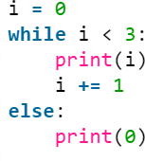

Find the output *

1/1

0 1 2 3 0

0 1 2 0

0 1 2

Error



Point out the wrong statement *

1/1

Series is 1D labeled homogeneously-typed array

DataFrame is general 2D labeled, size-mutable tabular structure with potentially heterogeneously-typed columns

Panel is generally 2D labeled, also size-mutable array

None of the above



Which statement is correct? *

1/1

List is mutable & Tuple is immutable List is immutable & Tuple is mutable Both are Mutable.

Both are Immutable



Which of the following is contained in NumPy library? *

1/1

n-dimensional array object

tools for integrating C/C++ and Fortran code fourier transform

All of the above

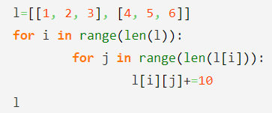

Find the Output *

1/1

No output Error

[[1, 2, 3], [4, 5, 6]]

[[11, 12, 13], [14, 15, 16]]



is an integer index based method, so you have to specify rows and 1/1

columns by their integer index to select data from the dataframe. *

iloc loc Both

None



Find the Output

1/1

aeoubcdfg aeioubcdfg aeiubcdfg

aeiiubcdfg





Which of the following packages is used for web scraping? *

1/1

beautiful soup tensorflow pytorch

keras



How would you cast the string variable “a” that is equal to “2” into the

integer 2? *

1/1

castToInt(a) int(a) integer(a)

castToInteger(a)



Which of the following is a valid dictionary in Python? *

1/1

myExample = {‘someItem’=>2, ‘otherItem’=>20} myExample = {‘someItem’: 2, ‘otherItem’: 20} myExample = (‘someItem’=>2, ‘otherItem’=>20)

myExample = (‘someItem’: 2, ‘otherItem’: 20)

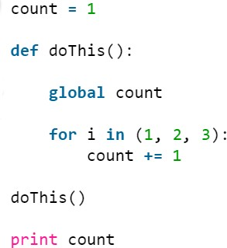

Find the Output. Edit: Print statement will include () *

1/1

Error 4

3

0



Assume, you are given two lists: a = [1,2,3,4,5], b = [6,7,8,9]. The task is to 0/1

create a list which has all the elements of a and b in one dimension. *

a.append(b) a.extend(b)

Any of the above

None of these



What is the difference between the two data series given below? 0/1

Assuming we have a data set df = pd.DataFrame(['ff', 'gg', 'hh', 'yy'],[24, 12, 48, 30],columns = ['Name', 'Age','X','Y'] ) *

1 is view of original dataframe and 2 is a copy of original dataframe. 2 is view of original dataframe and 1 is a copy of original dataframe. Both are copies of original dataframe.

Both are views of original dataframe



You want to read a website which has url as “w ww.abcd.org”. Which of 1/1

the following options will perform this task? *

urllib2.urlopen("w ww.abcd.org") requests.get("w ww.abcd.org") Both A and B

None of these



To read the title of the webpage you are using BeautifulSoup. What is the 1/1 code for this? Edit: Brackets are missing in the print statement present in the options *

A) B)

None of the above

C)

We have a multi-class classification problem for predicting quality of wine on the basis of its attributes. The data is loaded in a dataframe “df”.The quality column currently has values 1 to 10, but we want to substitute this by a binary classification problem. You want to keep the threshold for classification to 5, such that if the class is greater than 5, the output should be 1, else output should be .Which of the following codes would help you perform this task? Edit: In all the options there is a typo . quality should be in between ' ' i.e. 'quality'. Please assume the change and continue with the question. *

1/1

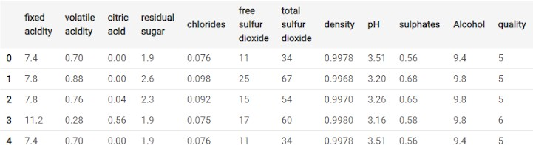

A) B)

None of the above





C)

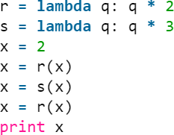

Find the Output. Edit: Print statement will include () *

1/1

24

12

48

None of the above

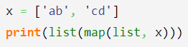

Find the Output *

1/1

[‘a’, ‘b’, ‘c’, ‘d’]

[[‘ab’], [‘cd’]] [['a', 'b'], ['c', 'd']]

None of the above

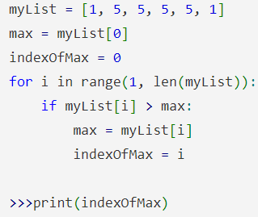

Find the output *

1/1

1

2

3

4

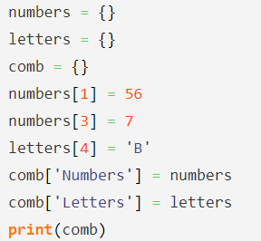

Find the Output *

1/1

Error, dictionary in a dictionary can’t exist ‘Numbers’: {1: 56, 3: 7}

{‘Numbers’: {1: 56}, ‘Letters’: {4: ‘B’}}

{‘Numbers’: {1: 56, 3: 7}, ‘Letters’: {4: ‘B’}}



Which of the following is an invalid statement? *

1/1

abc = 1,000,000

a b c = 1000 2000 3000

a,b,c = 1000, 2000, 3000

a_b_c = 1,000,000



This content is neither created nor endorsed by Google. - [T erms of Service](https://policies.google.com/terms) - [P rivacy Policy](https://policies.google.com/privacy)

[Forms](https://www.google.com/forms/about/?utm_source=product&utm_medium=forms_logo&utm_campaign=forms)